Лабораторная работа 4 по Ассемблеру

Задание 1.

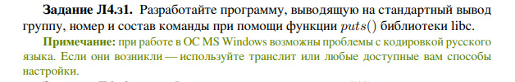

void task1()

{

puts("Group: PIN\n"

"Number: 24\n"

"Member: Miloserdova Lidiia\n");

}

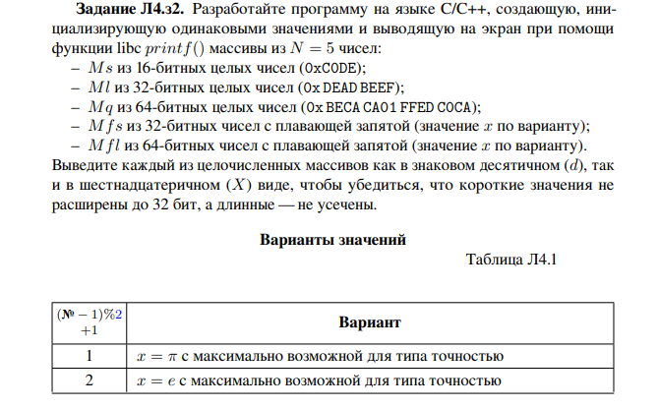

void task2()

{

cout << "16 bit" << endl;

int const N = 5;

__int16 arr_s[N];

for (int i = 0; i < N; i++)

{

arr_s[i] = 0xC0DE;

printf("10: %6hd 16: %4hx\n", arr_s[i], arr_s[i]);

}

cout << "32 bit" << endl;

__int32 arr_l[N];

for (int i = 0; i < N; i++)

{

arr_l[i] = 0xDEADBEEF;

printf("10: %11d 16: %8x\n", arr_l[i], arr_l[i]);

}

cout << "64 bit" << endl;

__int64 arr_q[N];

for (int i = 0; i < N; i++)

{

arr_q[i] = 0xBECACA01FFEDC0CA;

printf("10: %21lld 16: %16llx\n", arr_q[i], arr_q[i]);

}

cout << "32 bit real" << endl;

float arr_fs[N];

const double PI = 3.141592653589793;

for (int i = 0; i < N; i++)

{

arr_fs[i] = PI;

printf("%.7f\n", arr_fs[i]);

}

cout << "64 bit real" << endl;

__int64 arr_fl[N];

double fl[N];

for (int i = 0; i < N; i++)

{

fl[i] = PI;

printf("%.16lf\n", fl[i]);

}

}

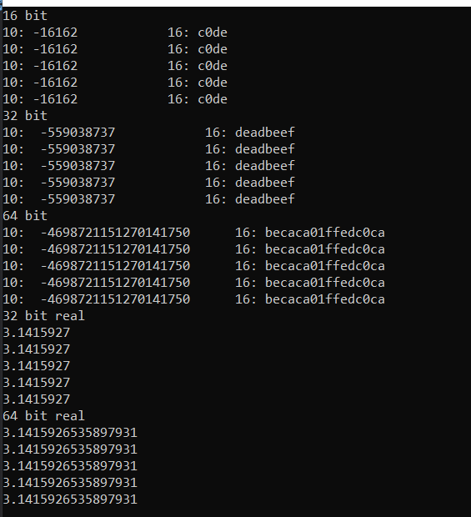

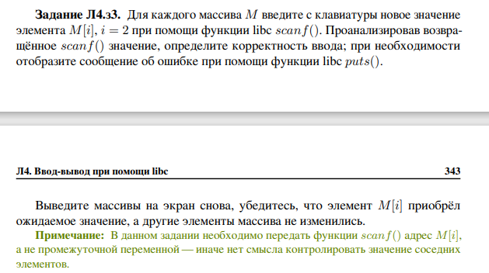

void task3()

{

cout << "16 bit" << endl;

int const N = 5;

__int16 arr_s[N];

for (int i = 0; i < N; i++)

{

arr_s[i] = 0xC0DE;

printf("10: %6hd 16: %4hx\n", arr_s[i], arr_s[i]);

}

cout << "Введите число: ";

scanf("%hd", &arr_s[2]);

for (int i = 0; i < N; i++)

{

printf("10: %6hd 16: %4hx\n", arr_s[i], arr_s[i]);

}

cout << "32 bit" << endl;

__int32 arr_l[N];

for (int i = 0; i < N; i++)

{

arr_l[i] = 0xDEADBEEF;

printf("10: %11d 16: %8x\n", arr_l[i], arr_l[i]);

}

cout << "Введите число: ";

scanf("%d", &arr_l[2]);

for (int i = 0; i < N; i++)

{

printf("10: %11d 16: %8x\n", arr_l[i], arr_l[i]);

}

cout << "64 bit" << endl;

__int64 arr_q[N];

for (int i = 0; i < N; i++)

{

arr_q[i] = 0xBECACA01FFEDC0CA;

printf("10: %21lld 16: %16llx\n", arr_q[i], arr_q[i]);

}

cout << "Введите число: ";

scanf("%lld", &arr_q[2]);

for (int i = 0; i < N; i++)

{

printf("10: %21lld 16: %16llx\n", arr_q[i], arr_q[i]);

}

cout << "32 bit real" << endl;

float arr_fs[N];

const double PI = 3.141592653589793;

for (int i = 0; i < N; i++)

{

arr_fs[i] = PI;

printf("%.7f\n", arr_fs[i]);

}

cout << "Введите число: ";

scanf("%f", &arr_fs[2]);

for (int i = 0; i < N; i++)

{

printf("%.7f\n", arr_fs[i]);

}

cout << "64 bit real" << endl;

double arr_fl[N];

for (int i = 0; i < N; i++)

{

arr_fl[i] = PI;

printf("%.16lf\n", arr_fl[i]);

}

cout << "Введите число: ";

scanf("%lf", &arr_fl[2]);

for (int i = 0; i < N; i++)

{

printf("%.16lf\n", arr_fl[i]);

}

}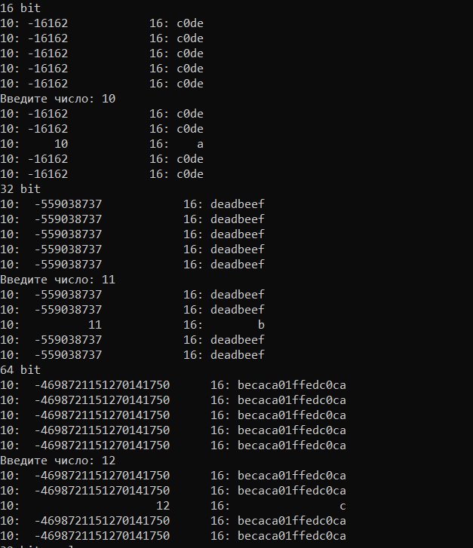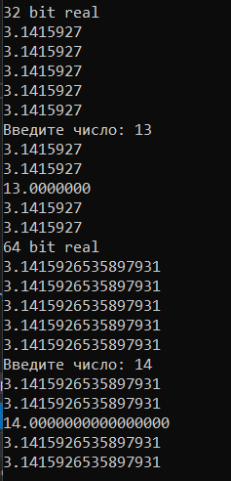

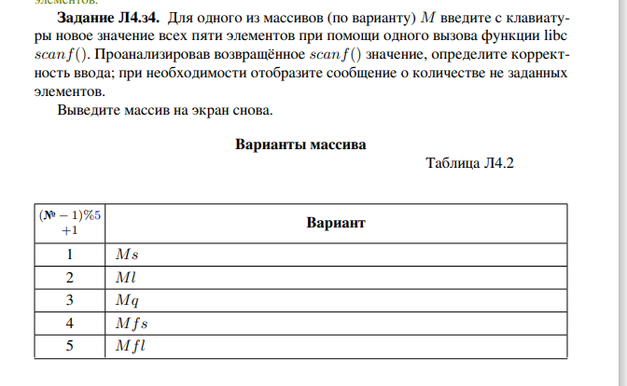

void task4()

{

int const N = 5;

cout << endl << "16 bit" << endl;

__int16 arr_s[N];

cout << "Введите числа: ";

int count = scanf("%hd%hd%hd%hd%hd", &arr_s[0], &arr_s[1], &arr_s[2], &arr_s[3], &arr_s[4]);

if (count == N)

for (int i = 0; i < N; i++)

{

printf("10: %hd 16: %hx\n", arr_s[i], arr_s[i]);

}

else printf("Неверный формат ввода(Введите 5 чисел): %d\n", count, N);

}

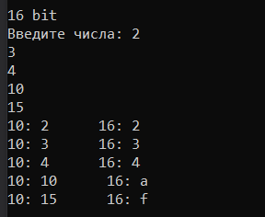

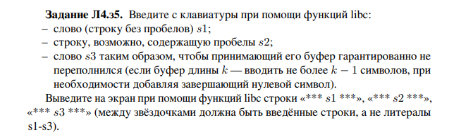

void task5()

{

char buf[256] = "";

cout << endl << "Введите строку без пробела: ";

scanf("%s", buf);

string without_space(buf);

cout << without_space << endl;

getline(cin, without_space);

cout << endl << "Введите строку с пробелом: ";

string with_space;

getline(cin, with_space);

cout << with_space << endl;

cout << endl << "Введите не более 255 символов: ";

char buffer[256] = "";

scanf("%255[^\n]", buffer);

string buf(buffer);

cout << buf << endl;

}

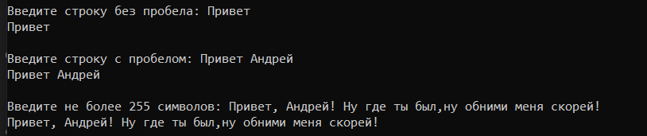



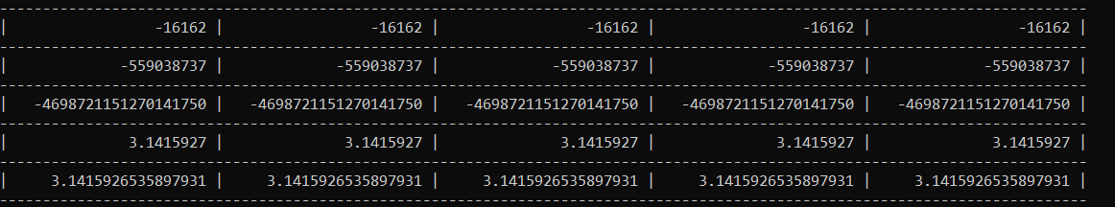

void task6()

{

printf("------------------------------------------"

"------------------------------------------"

"------------------------------------------\n");

int const N = 5;

__int16 arr_s[N];

for (int i = 0; i < N; i++)

{

arr_s[i] = 0xC0DE;

printf("| %22hd ", arr_s[i]);

}

printf("|\n");

printf("------------------------------------------"

"------------------------------------------"

"------------------------------------------\n");

__int32 arr_l[N];

for (int i = 0; i < N; i++)

{

arr_l[i] = 0xDEADBEEF;

printf("| %22d ", arr_l[i]);

}

printf("|\n");

printf("------------------------------------------"

"------------------------------------------"

"------------------------------------------\n");

__int64 arr_q[N];

for (int i = 0; i < N; i++)

{

arr_q[i] = 0xBECACA01FFEDC0CA;

printf("| %22lld ", arr_q[i]);

}

printf("|\n");

printf("------------------------------------------"

"------------------------------------------"

"------------------------------------------\n");

float arr_fs[N];

const double PI = 3.141592653589793;

for (int i = 0; i < N; i++)

{

arr_fs[i] = PI;

printf("| %22.7f ", arr_fs[i]);

}

printf("|\n");

printf("------------------------------------------"

"------------------------------------------"

"------------------------------------------\n");

double arr_fl[N];

for (int i = 0; i < N; i++)

{

arr_fl[i] = PI;

printf("| %22.16lf ", arr_fl[i]);

}

printf("|\n");

printf("------------------------------------------"

"------------------------------------------"

"------------------------------------------\n");

}